One D&D
A Karak Module
  - By L_PT

Objective of the Game
The Player who has collected the most treasure becomes the victor. The game ends once any Player defeats the strongest monster of the game - THE DRAGON - and loots its treasure with a ruby. Each Player counts the points from their treasure; treasure collected from chests or by defeating The Fallen is worth Victory Point (VP); the dragon ruby is Worth 1,5 VP. The Player with the most VPs wins the game.

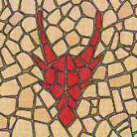
Setup
- Place the starting dungeon tile (coloured back) in the middle of the table.
- Shuffle the remaining tiles and place them to the side, face down, so that every player can reach them.
- Each player receives one inventory sheet and five Short Rest tokens, which they place on the inventory sheet.
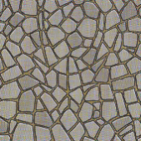
- Each player picks one hero card, either of their own choice or randomly (whichever the players agree on), and places it on the inventory sheet.
- Each player is given their Hero’s character sheet.
- Fit the hero figures into their respective plastic stands and place them on the starting tile.
- Roll a d20 dice to determine starting player, then go in the order of the next highest roll.

The Gameplay
The active player has 4 moves, meaning they can move up to 4 tiles. During these moves, one of the following situations will occur:
- Entering an undiscovered zone
- Initiating combat
- Joining combat
- Moving over a discovered zone

Entering an Undiscovered Tile
When moving into an Undiscovered Tile, the player takes one dungeon tile, connects it to the tile they are leaving and moves their hero onto the new tile. The new tile must be continuous only with the tile from which the hero came. All other routes are allowed to form a dead end.
- Tunnel - If the new tile contains a tunnel, nothing special happens and the player can move on, if this was not their 4th move.
- Room - If the new tile contains a room, the player draws one token from the bag of monsters and treasures.
  - If a Treasure was drawn, the player places it on the new tile and can still move on, if this was not their 4th move.
  - If a Treasure was drawn and the player owns a Key, they can collect the treasure and discard the key. In this case the player’s turn is over.
  - If a monster was drawn, the player places it on the tile and initiates combat.
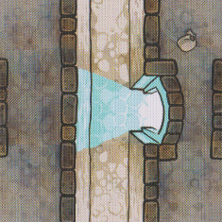
- Teleportation Gate - If the new tile contains a Teleportation Gate (TG) and there is only one discovered TG in the whole dungeon, it is inactive and cannot be used. If there are more TGs in the dungeon, the player can move between them, spending only one move to teleport from the neighbouring tile into the other side of the portal.
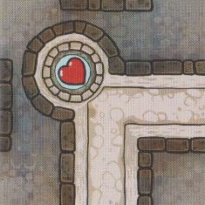
- Healing Fountains - If the new tile contains a Healing Fountain (HF), players may decide to heal themselves with a Long Rest, thus ending their turn right away. Otherwise, they can still move on, taking a Short Rest. For detail see Hit Points & Healing.

Initiating Combat
When entering a tile with a Monster that is currently not in combat, the player initiates combat with it. The following steps happen:
- The Player and the Monster roll a d20 and add their Initiative. Whoever rolls highest acts first for the remainder of the battle.
- During the first turn of combat, both the player and the monster may only use their items, this includes weapons and scrolls. The player cannot try to flee and neither them nor the monster may use their Combat Features (CF).
- Starting at the second turn, the player may try to flee, triggering an attack of opportunity from the Monster.
- Also, from the second turn onwards, both the player and the Monster can use their CF instead of their items.
If all players agree upon it at the start of the game, then Player versus Player combat (PvP) is allowed. It can be initiated willingly as long as both players are on the same tile. There are no direct benefits to defeating a player in combat.
During one turn of combat, one of the following things may happen:
- Making a Weapon Attack
You make a weapon attack with your starting equipment and add any bonuses from your weapons as described in The Equipment. Your attack lands if your d20 roll + your Attack Modifier is equal to or higher than the target’s Armor Class (AC). If it hits, you can then roll damage. During this phase you can also use up to 3 Flame Scrolls.
- Using a Healing Scroll
You use the Healing Scroll as described in The Equipment. You automatically leave combat, and the Monster cannot take an opportunity attack.
- Fleeing Combat
Starting at the second turn, you can try to flee. This allows you to escape to the tile you came from but triggers an opportunity attack from the Monster, this means they get a free Weapon Attack on you.
- Using your Combat Feature
Starting at the second turn, you use your action to activate your Combat Feature. Follow the instruction as described under your Hero.
- Using Spellcasting
Starting at the second turn, you use one of the spells you know, so long as you still have spell slots for levelled spells. Follow the instruction as described under The Equipment.
At the end of the first turn, or any other turn after that, one of these outcomes may happen:
- The Monster is defeated
The Player moves onto the Monster’s tile, collects whatever loot the Monster dropped and finishes their turn.
- The Hero is defeated
The Player is knocked unconscious and remains in the tile they are on. They are reduced to 0 Hit Points (HP). If they still have Short Rests, they will regain one Hit Dice worth of HP on the next turn. They may only start playing again on the turn after that. If they don’t have any Short Rests left, they are teleported to the nearest HF. They may only use the HF on their next turn. The Monster regains all its HP if there are no other players in combat.

- Neither party is defeated
The Player ends his turn; the next player gets to play. On the Player’s next turn, they are still in combat.
- One of the parties escapes combat or is incapacitated
The Player may still use their 4 moves after leaving combat. Whether the Monster gets an opportunity attack, and whether the Player must return to their original tile is dependent on what ability or action is used to escape. The Monster regains all their HP, but the Player does not.

Joining Combat
Any Player can choose to join ongoing combat between another player and a Monster. They will roll Initiative against the Monster and their combat will act independently of other Players’ except for the Monster’s HP. Whoever deals the final blow moves on to the Monster’s tile while the other players stay in their tiles.

Allies in Combat
Creatures other than the Hero, such as the Familiars, Lady Lorraine’s Bear Companion and Doctor Sidhar’s Eldritch Cannon can act in combat. Unless specified otherwise, they roll their own initiative and follow the rules of Joining Combat, except they act for the Hero that summoned them.

Moving to a Discovered Tile
When moving through the discovered zone, the hero moves along continuous tiles.
- Even when moving over a discovered zone, the hero is still limited to 4 moves.
- If there is a Monster in a room, the Player cannot pass it and must fight it.
- If the Player wants to collect an equipment lying on a tile, unlock a chest or Long Rest at the HF, they must finish their turn on that tile. A player can therefor prematurely finish their turn in order to do one of these actions.
- Monsters and treasures spawn in rooms only when the rooms are discovered for the first time.

End of the Game
The game ends immediately after one of the Heroes defeats the Dragon in combat. The Hero who defeated the beast will get its treasure, but that doesn’t mean they are automatically declared winner. The winner is the player who has the most VP at the very moment the game ends. It may thus happen that a player becomes the winner without being the one who defeated the Dragon.

Hit Points & Healing
Each Hero has a different maximum Hit Points (HP), type of Hit Dice (HD) and Constitution modifier (CON), as described in The Heroes but all have 5 HD.
When a Player walks through a HF, they can choose not to stop, therefor taking a Short Rest, to expend up to 2 of their remaining HD and heal for the result plus CON.
If they instead choose to finish their turn on a HF, or take a Long Rest, they will regain 10 HP + CON, get back all their HD and their Spell Slots, and lose the Curse of Karak.

The Equipment
Anytime a player defeats a monster, they take the Loot Equipment (LE) that is shown on the other side of the monster token. The player places the equipment on the equipment sheet.
The equipment sheet has two slots for weapons, three slots for scrolls and one slot for a key. A player can only place the equipment into its respective slot. This means a player can only have two weapons, three scrolls and one key at the same time. If they want to get additional equipment, they must discard one piece of equipment they already possess onto the tile the Player is currently occupying.
There are also two types of damage in this game, fire and physical. Mummies take double damage from fire.

Weapons
There are three types of loot weapons – daggers, swords, and axes. They can be received by defeating a Rat, Skeleton Warrior, or Skeleton King. A weapon can also be received by collecting it when finishing your turn on a tile where another player left it. When a player collects a weapon, they place it on one of the two possible slots for weapons. Each weapon adds a unique bonus to the players’ Starting Equipment (SE) based on which slot the weapon is placed in. At any given moment, a player can thus own a maximum of two loot weapons.
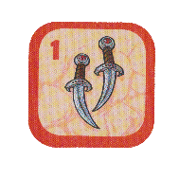
- Daggers
If the daggers are placed on the Main Slot (top slot), the Player’s Attack Bonus becomes 0 if it is negative.
If they are placed on the Off-Hand Slot (bottom slot), the Player can perform an extra attack for 1d4 base damage when taking the Attack action.
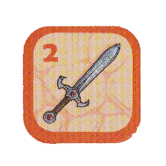
- Sword
If the sword is placed on the Main Slot, the Player adds +1 to both their Attack Bonus and their Damage Bonus.
If it is placed on the Off-Hand Slot, the Player can perform an extra attack for 1d6 base damage when taking the Attack action.
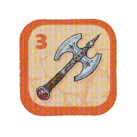
- Axe
If the axe is placed on the Main Slot, the Player’s Damage Bonus gains +2 if it is negative and gains +1 if it is positive.
If it is placed on the Off-Hand Slot, the player can perform an extra attack for 1d10 base damage when taking the Attack action.

Scrolls
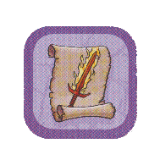
There are two types of scrolls in the game: Flame and Healing. Once a Player obtains a scroll, they place it in one of the scroll slots. After using a scroll, the Player discards it from the game (meaning they do not return it to the bag).
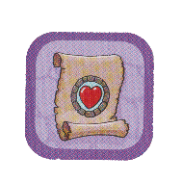
Flame: The Flame Scroll can be acquired by defeating a Mummy. When using it, you add an additional 1d4 + Wisdom (WIS) Fire damage to your attack. You can choose whether to use the scroll after rolling your damage. In addition, more than one Flame Scroll can be used during one action.
Healing: The Healing Scroll can be acquired by defeating a Giant Spider. The Healing Scroll can be used either on the caster or on any other player. The target is then moved to any revealed HF and makes a Long Rest. This does not cost any moves, and it does not end the turn. Thus, it can be used any time during the caster’s turn. If used during combat, you automatically leave, and the Monster cannot take an opportunity attack.

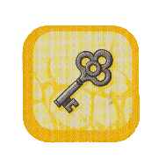
Key and Treasure
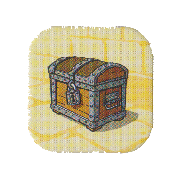
A key can be acquired by defeating a Skeleton Turnkey. After receiving it, the Player places it on the hero card in the key slot. Each Player can thus own a maximum of one key.
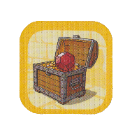
A key can be used to unlock any chest. To unlock a chest, the player must end their turn on a tile with a chest, collect the treasure and discard the key from the game (meaning they do not return it to the bag). Anytime a player owns more pieces of equipment than they are entitled to, they must place the excess equipment of their choice on the tile where they are standing, making it accessible for the other players to collect it.
Defeating the Dragon also awards the Player with treasure: A regular chest of 1 VP containing a Ruby that is worth ½ VP. This means that defeating the Dragon, rewards the player with 1,5 VP, and not with automatic victory.
In addition to loot, there are two other types of equipment. The player’s and monster’s Starting Equipment (SE) as well as the Wizard, the Warlock, and the Cleric’s spells. The SE is the base of the Attack action and is merely amplified by the Loot Equipment (LE).

Starting Equipment
- Sword
The most classic of blades. The Sword allows the wielder to perform an attack that deals a base damage of 1d6.
- Sword and Dagger
Clever and cunning. The Sword and Dagger allow the wielder to perform two attacks that deal a base damage of 1d4 each.
- Sword and Shield
A Fighter’s classic set. The Sword and Shield allow the wielder to perform an attack that deals a base damage of 1d6 as well as increasing their Armor Class (AC) by +2 as long as there is no LE on the Off-Hand Slot.
- Battleaxe
A weapon of brute force. The Battleaxe allows the wielder to perform an attack that deals a base damage of 1d10.
- Barbarian Battleaxe
Any Barbarian’s weapon of choice. The Barbarian Battleaxe allows the wielder to perform an attack that deals a base damage of 1d8.
- Flail
A fancy, but still simple blade. The Flail allows the wielder to perform an attack that deals a base damage of 1d6.
- Fate Weaver’s Halberd
A blade of absolute Wisdom. The Fate Weaver’s Halberd allows the wielder to perform an attack that deals a base damage of 1d6. If both LE slots are occupied, the wielder also gains a +1 to their Attack Modifier.
- Spear
The most traditional weapon. The Spear allows the wielder to perform an attack that deals a base of 1d6 damage.
- Club
The bluntest of weapons. The Club allows the wielder to perform an attack that deals a base of 1d8 damage.
- Smack
The best way to use one’s arms when they’re unarmed. The someone in question smacks the target, dealing 1d6 base damage.
- Pinch
The truest crustacean weapon. The attacker pinches the foe, dealing 1d8 base damage.
- Whisp
A fallen soul does not require a blade to enter one’s body. The Fallen reaches into the target, dealing 1d10 base damage.
- Claws
Similar to a Smack, but significantly more painful. The Dragon launches its claws at the target, dealing a base 1d12 damage.
- Bite
Simple, yet effective. The wielder of the mouth performs a Bite, dealing 1d4 base damage and, if knocking the target unconscious (bringing it to 0 HP), causing them to drop one of their Loot Equipment weapons.
- Peck
A closed-mouth bite. The wielder of the beak performs an attack at the Target’s eye, dealing 1d4 base damage and giving it disadvantage on its next attack.

Spells
There are two types of spells – cantrips and levelled spells. Cantrips can be cast at will, however Levelled Spells require a Spell Slot to be cast. Every spellcaster has 2 Spell Slots that regenerate after a Long Rest. Levelled Spells can also be cast using two Spell Slots instead of one for increased power, this is called “Up-Casting”.
Cantrips
- Firebolt - Make an Attack Roll. You deal 1d6 + WIS Fire damage.
- Ray of Frost - Make an Attack Roll. You deal 1d4 + WIS damage and the target cannot flee.
- Eldritch Blast - Make an Attack Roll. You deal 1d6 + WIS damage.
- Blade Ward - You have resistance against physical damage you take next turn.
- Sacred Flame - The target rolls a d20 and adds their WIS. If the result is lower than 12 plus your Wisdom, the target takes 1d10 + WIS Fire damage. This ignores advantages and disadvantages.
- Guidance - You or an ally of your choice gains advantage on their next attack if you don’t take damage until then. If you have a weapon in your off-hand slot, you can still make an attack with it.
- Acid Splash - Make an Attack Roll. You deal 1d4 + WIS damage. The target rolls a d20 and adds their CON. If the result is lower than 12 plus your Wisdom, the target takes an additional 1d6 + WIS damage.
Levelled Spell
- Magic Missiles - You deal 3d4 damage. It always hits. If Up-Cast: You add your WIS to each damage roll.
- Sleep - Make an Attack Roll. If the target’s Wisdom is lower than +2, it falls asleep until your next turn or until someone initiates combat with it, whichever comes first. Until then, its tile is treated as if it were empty. If Up-Cast: You gain advantage on the attack roll.
- Inflict Wounds - You deal 2d10 damage to a target. You must touch it, so you cannot flee on your next turn. If Up-Cast: You deal 3d10 damage.
- False Life - You gain 8 Temporary HP that disappear after you leave the fight. If Up-Cast: You heal 1d4 + WIS HP and gain 10 Temp HP instead.
- Guiding Bolt - Make an Attack Roll. You deal 2d8 + WIS damage and you or your allies’ next attack against the target has advantage. If Up-Cast: The advantage happens even if you fail.
- Protection from Evil - Giant Spiders, The Fallen and Mummies have disadvantage on attacks against you until your next turn. If Up-Cast: The spell lasts until your next Short Rest of Long Rest.
- Divine Smite - You can cast this spell after succeeding on an attack roll. You deal an additional 1d8 Fire damage. If Up-Cast: You deal an additional 2d8 + 2 Fire damage instead.
- Hunter’s Mark - You mark a Monster as your Prey. All damage you or your allies deal against it do an additional 2 damage. You can only have one Prey marked at a time. If Up-Cast: Attacks deal an additional 1d4 + 1 damage instead.
- Find Familiar - You summon a Familiar (except the Eldritch Cannon) that joins your ongoing combat against the Monster. It disappears upon reaching 0 HP or when combat ends. You can only have 1 Familiar at a time. If Up-Cast: The Familiar does not disappear once combat ends.

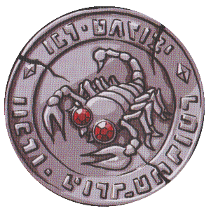
The Curse of Karak
If any player defeats a Mummy, one player becomes cursed. The Player who defeated the Mummy chooses another player and places the curse token on their inventory sheet. The Player whose Hero was cursed and has the curse token on their Hero’s card cannot use their hero’s Health, Attack and Move Skills but can still use their Combat Feature.
The curse can be lifted by finishing one’s turn on a tile with a HF and removing the curse token along with restoring all HPs, HDs, and Spell Slots. The curse can also be passed on when another Mummy is defeated, and the Player moves the curse token to another player. However, the token does not have to be moved; it can stay with the previous owner.

The Heroes

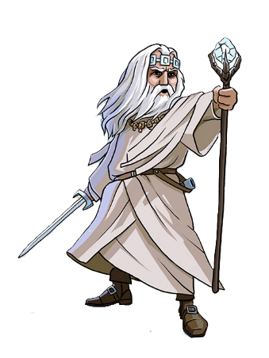
Argentus, the Wizard
Physicality 0 | Constitution -1 | Wisdom +2
Hit Dice d6 | Max HP 30 | Armor Class 11

Attack Mod +3 | Damage Mod 0 | Initiative +1
Health Skill Arcane Recovery
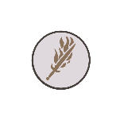
When taking a Short Rest, Argentus regains one Spell Slot.
Attack Skill Spell Mastery

Argentus does not consume the Flame Scroll when using it.
Movement Skill Astral Walking
Argentus can move through walls into discovered tiles.
Starting Equipment Sword
Combat Feature Spellcasting
Firebolt, Ray of Frost, Magic Missiles, Sleep

Lord Xanrus, the Warlock
Physicality -2 | Constitution +2 | Wisdom +1
Hit Dice d8 | Max HP 40 | Armor Class 10
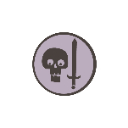
Attack Mod +3 | Damage Mod -2 | Initiative -1
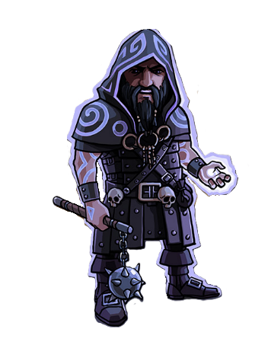
Health Skill Sacrifice
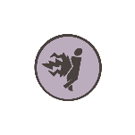
Lord Xanrus can sacrifice 6 hp to add 1d12 to the damage of his attack. He can choose to do so after rolling the dice but can gain the bonus only once per combat. He can also sacrifice his last HP but then fall unconscious for his next turn.
Attack Skill Repelling Blast

Lord Xanrus’ Eldritch Blast spell knocks the Monster back on a hit. This means it cannot act if it goes after him in Initiative order.
Movement Skill Magic Swap
Lord Xanrus can swap his position with any other hero. This action costs 4 moves so it can be performed only at the beginning of his turn. When swapping with a Player in combat, he can chose whether to resume combat or not and vice-versa for the swapped Player if Lord Xanrus was in combat.
Starting Equipment Flail
Combat Feature Spellcasting
Eldritch Blast, Blade Ward, Inflict Wounds, False Life

Horan, the Ancestral Guardian
Physicality +1 | Constitution +2 | Wisdom -2
Hit Dice d10 | Max HP 35 | Armor Class 12

Attack Mod -1 | Damage Mod +1 | Initiative +2
Health Skill Relentless

If Horan loses his last HP, he does not fall unconscious like other weaklings, instead he teleports to a HF. He can use it on the next turn.
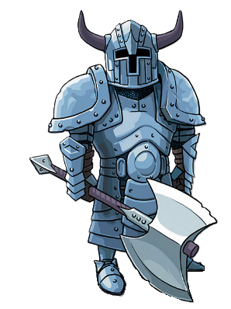
Attack Skill Extra Attack

Horan has two attacks with his SE per turn instead of one, unless both LE slots are occupied.
Movement Skill Fast Movement
Horan has 5 moves per turn instead of 4.
Starting Equipment Barbarian Battleaxe
Combat Feature Ancestral Protector
Horan calls upon his ancestors to create a spirit shield. For the next two turns or until the end of combat, whichever comes first, Horan takes 1d4 less damage from all attacks and deals the same amount of damage back to the attacker.

Aderyn, the Assassin
Physicality +1 | Constitution -1 | Wisdom +1
Hit Dice d8 | Max HP 25 | Armor Class 12
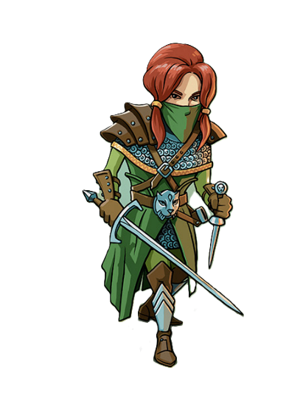

Attack Mod +2 | Damage Mod +1 | Initiative +2
Health Skill Evasion

If the Monster’s attack roll hits Aderyn’s AC by a two-point difference (12 or 13), she evades the attack.
Attack Skill Sneak Attack
Aderyn does an additional d6 of damage if she attacks from being Hidden during combat. She also deals another d6 of damage on the first turn of combat if Aderyn was on the monster’s tile when combat begins.
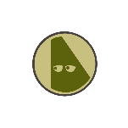
Movement Skill Stealth Expertise
Aderyn can ignore monsters, passing by their tile and finishing her turn on it without initiating combat if she so chooses.
Starting Equipment Sword and Dagger
Combat Feature Hide
Aderyn can use her turn in combat to Hide. This will use her action but give her advantage on attacks during her next turn and activate Sneak Attack. If she goes before the Monster, it will also have disadvantage on attacks against her while she is hidden.

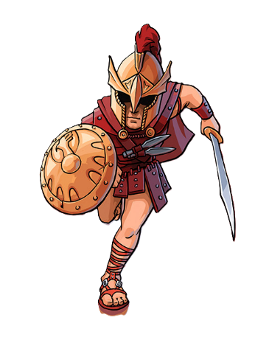
Victorius, the Champion
Physicality +1 | Constitution 0 | Wisdom 0
Hit Dice d10 | Max HP 30 | Armor Class 13
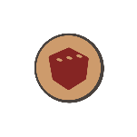
Attack Mod +1 | Damage Mod +1 | Initiative +2
Health Skill Second Wind

When Victorius rolls a 3 on any dice, he regains 3 HP.
Attack Skill Great Weapon Fighting
When Victorious rolls a 1 on his damage rolls, he can reroll it.
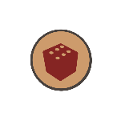
Movement Skill Action Surge
If Victorius rolls the maximum amount on either one of his attack rolls or one of his damage dice, he can continue his turn afterwards. This means he can continue if he defeats the monster or attack again before the monster gets its turn. He cannot perform additional attacks if attacking for a second time.
Starting Equipment Sword and Shield
Combat Feature Disengage
Victorius can flee combat without triggering an opportunity attack from the monster. He can also flea past the monster into undiscovered tiles.

Taia, the Cleric
Physicality +1 | Constitution -1 | Wisdom +1
Hit Dice d6 | Max HP 25 | Armor Class 14
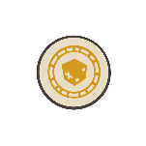
Attack Mod +2 | Damage Mod +1 | Initiative +2
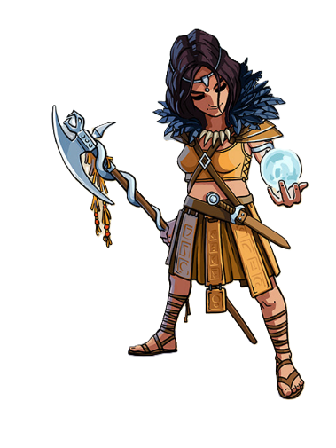
Health Skill Disciple of Life
Taia adds +2 to the results of HD rolls.
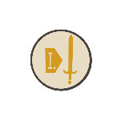
Attack Skill True Sight
Taia has advantage on her attack rolls if she triggered combat in her first move or started her turn during combat.

Movement Skill Arcane Eye
Taia can draw two tokens from the bag and choose which she wants to place into the dungeon. The other is put back into the bag.
Starting Equipment Fate Weaver’s Halberd
Combat Feature Spellcasting
Sacred Flame, Guidance, Guiding Bolt, Find Familiar

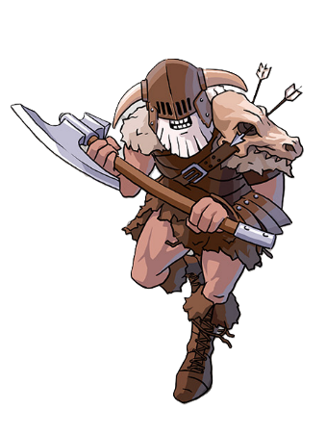
Valduk, the Berserker
Physicality +2 | Constitution +1 | Wisdom -2
Hit Dice d10 | Max HP 30 | Armor Class 14
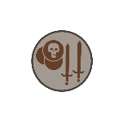
Attack Mod -1 | Damage Mod +2 | Initiative +3
Health Skill Berserk

If Valduk is below 20 HP, his Damage Modifier is increased by +1. If he is below 10 HP, it is increased by +2 instead.
Attack Skill Reckless

Valduk can grant himself advantage on his attacks for a turn, but the next attack against him will also have advantage.
Movement Skill Frenzy
If he doesn’t collect the loot after a combat is over, Valduk can continue his turn.
Starting Equipment Barbarian Battleaxe
Combat Feature Rage
Valduk can use his action on his turn to Rage. For the next two turns or until the end of combat, whichever comes first, Valduk is resistant to physical damage, this means he takes only half damage – rounded up – from non-fire attacks, and he has +1 to his Attack Modifier.

Baron Markul, the Paladin
Physicality +1 | Constitution -1 | Wisdom +1
Hit Dice d10 | Max HP 25 | Armor Class 12

Attack Mod +2 | Damage Mod +1 | Initiative +2
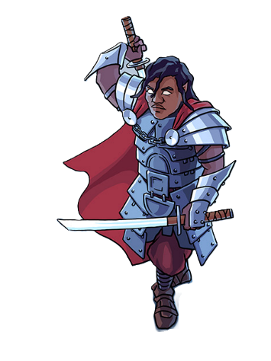
Health Skill Oath of Devotion
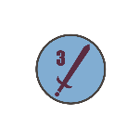
Baron Markul can cast Protection form Evil without expending a spell slot.
Attack Skill Dueling

Baron Markul’s Swords in the Main Slot grant an extra +1 to his Damage Modifier. His Swords in the Off-Hand Slot deal 1d6 + 1 damage instead.
Movement Skill Blitz Attack
Lord Xanrus can move to any discovered tile next to a Monster. This action costs 4 moves so it can be performed only at the beginning of his turn. He immediately enters in combat with the Monster on the neighbouring tile.
Starting Equipment Sword
Combat Feature Spellcasting
Blade Ward, Sacred Flame, Protection from Evil, Divine Smite

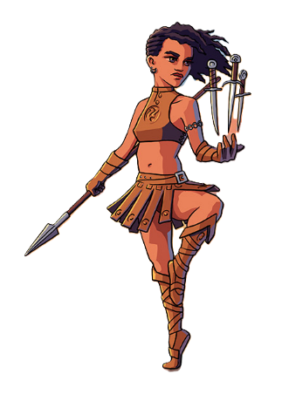
Hannah, the Thief
Physicality 0 | Constitution 0 | Wisdom +1
Hit Dice d8 | Max HP 25 | Armor Class 10

Attack Mod +2 | Damage Mod 0 | Initiative +1
Health Skill Reliable Talent
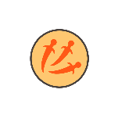
When rolling Hit Dice, any results under 4 are treated as a 4 by Hannah.
Attack Skill Throwing Daggers
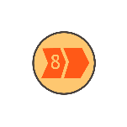
Hannah can store Daggers in the scroll slots. Each adds 1d4 damage to her main attack and isn’t consumed upon use. If she receives the Curse of Karak while having Daggers in her Scroll Slots, she can’t use or remove them.
Movement Skill Dash
Hannah can choose to Dash at the start of her turn. If she does, she has 8 movement that turn but can only travel across Discovered Tiles and collection Loot doesn’t end her turn.
Starting Equipment Spear
Combat Feature Thief’s Reflexes
Hannah prepares a cunning strike. On her next two turns, she can act before and after the Monster. This Combat Feature can only be used once per fight.

Lady Lorraine, the Ranger
Physicality +1 | Constitution -1 | Wisdom +1
Hit Dice d6 | Max HP 25 | Armor Class 11

Attack Mod +2 | Damage Mod +1 | Initiative +2
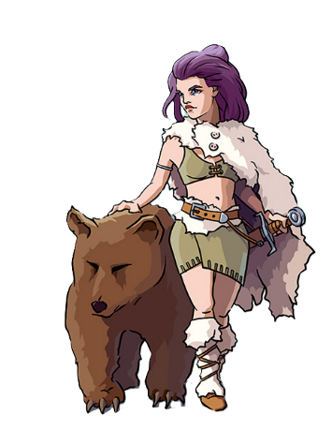
Health Skill Tireless

If Lady Lorraine uses all her movement on a single turn, she heals for 1d4 HP.
Attack Skill Beastmaster

When rolling a 1 on damage dice, Lady Lorraine doesn’t deal damage. Instead, her Bear Companion gets to make an attack for 1d4 + 2 damage after Lady Lorraine’s turn.
Movement Skill Natural Explorer
Lady Lorraine can expend 1 movement to discover a tile without moving onto it or entering combat. If she does so, she must then use her movement again to move to that tile.
Starting Equipment Sword
Combat Feature Spellcasting
Ray of Frost, Blade Ward, Hunter’s Mark, Find Familiar

Doctor Sidhar, the Artificer
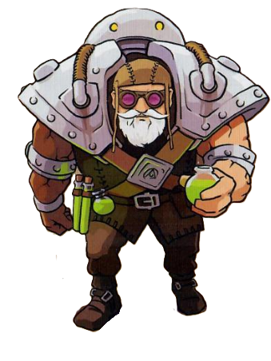
Physicality +1 | Constitution -1 | Wisdom +1
Hit Dice d8 | Max HP 30 | Armor Class 11

Attack Mod +2 | Damage Mod +1 | Initiative +2
Health Skill Armorer

Doctor Sidhar has 14 AC.
Attack Skill Artillerist

Doctor Sidhar can use a Spell Slot to summon an Eldritch Cannon. It disappears upon reaching 0 HP or when combat ends.
Movement Skill Alchemist
When taking a token from the bag, Doctor Sidhar can sacrifice 6 HP to take a different one. He can do so as many times as he wants. He can also sacrifice his last HP but then fall unconscious after placing the token.
Starting Equipment Smack
Combat Feature Spellcasting
Firebolt, Acid Splash, Magic Missile, Guiding Bolt

Elspeth, the Battle Master
Physicality +2 | Constitution -1 | Wisdom 0
Hit Dice d8 | Max HP 25 | Armor Class 12

Attack Mod +1 | Damage Mod +2 | Initiative +3
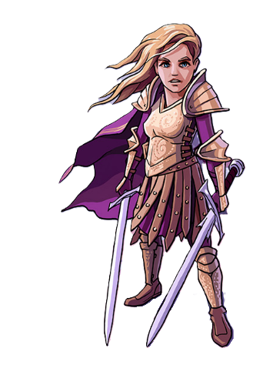
Health Skill Indomitable
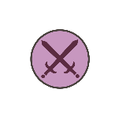
Elspeth can reroll each of her Hit Dice once. She must use the second roll.
Attack Skill Two Weapon Fighting
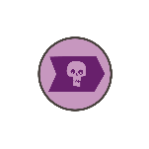
Weapons in Elspeth’s Off-Hand Slot also give the Main Slot bonuses.
Movement Skill Know Your Enemy
Elspeth can use one movement and sacrifice 6 HP to through a tile with a Monster without entering combat and moving to a neighbouring tile, including undiscovered tiles.
Starting Equipment Sword
Combat Feature Student of War
Elsbeth makes two attacks with her main weapon. If both fail, she gains advantage on her next turn. If both succeed, she heals 1d4 HP.

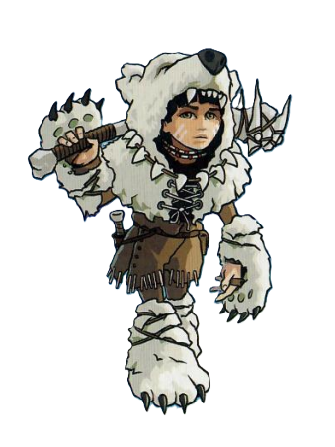
Kirima, the Wild Heart
Physicality 0 | Constitution -1 | Wisdom +2
Hit Dice d10 | Max HP 25 | Armor Class 12

Attack Mod +3 | Damage Mod 0 | Initiative +1
Health Skill Danger Sense

Kirima always goes first on Initiative order.
Attack Skill Ambush

Kirima has +1 to her Damage Modifier when fighting against a Monster on a tile that has already been discovered before her turn.
Movement Skill Nature Speaker
Kirima can summon a Familiar. It exists until it reaches 0 HP or until Kirima’s next Short Rest or Long Rest, whichever comes first. After using this skill, Kirima can only use it again after a Short Rest or Long Rest.
Starting Equipment Club
Combat Feature Aspect of the Beast
Kirima can use the Combat Feature of the Monster she is fighting.

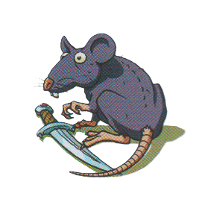
Bestiary

Rat
Physicality -1 | Wisdom -3 | Max HP 10
Attack Mod -2 | Damage Mod -1 | Initiative 0
Armor Class 8 | Equipment Bite
Combat Feature Flee
The Rat flees combat, exiting to a neighbouring tile that doesn’t have a Hero on it. It can flee to an undiscovered tile. If it flees to a tile with a token on it, they will stack, and if it is another Monster they will both be part of the same combat.
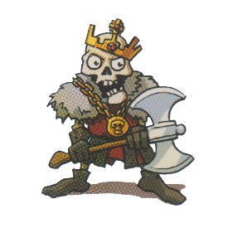

Skeleton King
Physicality +3 | Wisdom +1 | Max HP 30
Attack Mod +2 | Damage Mod +3 | Initiative +4
Armor Class 12 | Equipment Battleaxe
Combat Feature Greed
The Skeleton King steals one of the Hero’s scrolls, if they have any. He will drop it after death.
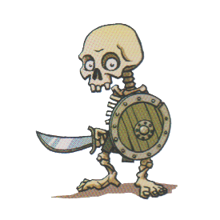

Skeleton Warrior
Physicality +2 | Wisdom 0 | Max HP 25
Attack Mod +1 | Damage Mod +2 | Initiative +3
Armor Class 13 | Equipment Sword
Combat Feature Cover
The Skeleton Warrior hides behind his shield. The next attack against him has disadvantage.
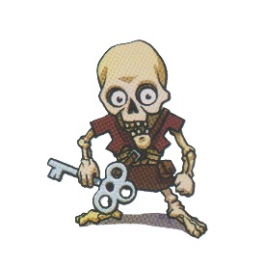

Skeleton Turnkey
Physicality +1 | Wisdom 0 | Max HP 15
Attack Mod +1 | Damage Mod +1 | Initiative +2
Armor Class 11 | Equipment Smack
Combat Feature Flee
The Skeleton Turnkey flees combat, exiting to a neighbouring tile that doesn’t have a Hero on it. It can flee to an undiscovered tile. If it flees to a tile with a token on it, they will stack, and if it is another Monster they will both be part of the same combat.

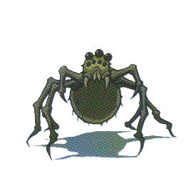
Giant Spider
Physicality +1 | Wisdom -3 | Max HP 15
Attack Mod -2 | Damage Mod +1 | Initiative +2
Armor Class 10 | Equipment Bite
Combat Feature Web
The Giant Spider webs the Hero down. They cannot flee combat until either them or the Giant Spider is defeated.

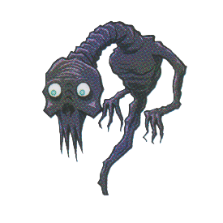
The Fallen
Physicality +2 | Wisdom +4 | Max HP 25
Attack Mod +5 | Damage Mod +2 | Initiative +3
Armor Class 15 | Equipment Whisp
Combat Feature Memories of the Past
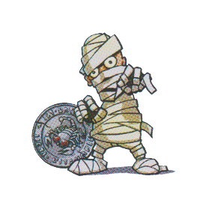
The Fallen can use the CF of the first Hero that initiated combat with it.

Mummy
Physicality +1 | Wisdom -1 | Max HP 20
Attack Mod 0 | Damage Mod +1 | Initiative +2
Armor Class 12 | Equipment Smack
Combat Feature Curse
The Mummy inflicts the Curse of Karak upon the player until the end of the combat.
Note: The Mummy takes double damage from Fire.

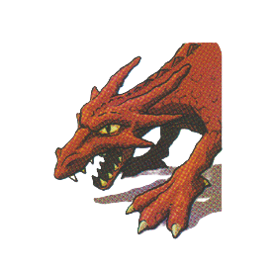
The Dragon
Physicality +3 | Wisdom +3 | Max HP 50
Attack Mod +4 | Damage Mod +3 | Initiative +4
Armor Class 14 | Equipment Claws
Combat Feature Fire Breath
The Dragon deals 1d8 Fire damage to every enemy in combat, it always hits.

Familiars
Familiars don’t have Combat Features, so all they can do is attack.

Eldritch Cannon
Physicality +1 | Wisdom +2 | Max HP 15
Attack Mod +3 | Damage Mod +1 | Initiative +2
Armor Class 13 | Equipment Eldritch Blast (Spell)

Raven
Physicality -1 | Wisdom +2 | Max HP 10
Attack Mod +3 | Damage Mod -1 | Initiative 0
Armor Class 8 | Equipment Peck

Crab
Physicality +3 | Wisdom -2 | Max HP 10
Attack Mod -1 | Damage Mod +3 | Initiative +4
Armor Class 12 | Equipment Pinch

Frog
Physicality 0 | Wisdom 0 | Max HP 10
Attack Mod +1 | Damage Mod 0 | Initiative +3
Armor Class 8 | Equipment Acid Splash (Spell)

Cat
Physicality 0 | Wisdom +1 | Max HP 10
Attack Mod +2 | Damage Mod 0 | Initiative +1
Armor Class 10 | Equipment Bite

Glossary
Nome | Description | Abbreviation
Victory Points | Points obtained from chests that define the victor. | VP
Physicality | One of the Heros’ and Monsters’ stats. Defines their Damage Modifier and their Initiative. | PHY
Constitution | One of the Heros’ stats. It is used when healing. | CON
Wisdom | One of the Heros’ and Mosters’ stats. Defines their Attack Modifier and it is used for Spellcasting. | WIS
Armor Class | Defines how difficult or easy it is to hit the Hero or Monster. | AC
Attack Modifier | The bonus added to the roll that defines whether the attack lands. It is calculated as: 1 + Wisdom. | No abbreviation
Damage Modifier | The bonus added to the damage roll if the attack lands. It is calculated as: 0 + Physicality.
Initiative | The bonus added to the roll that defines the order in combat. It is calculated as: 1 + Physicality.
Advantage | Roll the dice twice and take the highest result.
Disadvantage | Roll the dice twice and take the lowest result.
Hit Points | The Heros’ and Monster’s health. | HP
Temporary Hit Points | Hit Points that cannot be healed but can surpass the Hit Point maximum. | Temp HP
Hit Dice | The dice used to regain HP when taking Short Rests or after death. They are consumed upon use and are recharged when taking a Long Rest. | HD
Short Rest | Refers to healing at a HF without stopping. Uses HD. | No abbreviation
Long Rest | Refers to healing at a HF by finishing your turn. Recharges HP, HD and Spell Slots.
Healing Fountain | A special tile that allows you to heal. | HF
Teleportation Gate | A special tile that allows you to move to identical tiles. | TG
Starting Equipment | The Heros’ and Monsters’ main equipment. The base of their Attack action. | SE
Loot Equipment | The Hero’s looted items, used to buff their Attack action. It also includes Keys and Healing Scrolls. | LE
Combat Feature | A unique but basic ability used by Heros and Monsters during combat. | CF
Spell Slot | The number of times of Spellcaster can cast Levelled Spells. They recharge when taking a Long Rest. | No abbreviation
Cantrip | A weaker spell that can be cast as many times as the Spellcaster wants.
Levelled Spell | A stronger spell that consumes Spell Slots to be cast, so it is limited.
Up-Casting  (Up-Cast spell) | Using two Spell Slots to cast a more powerful version of a Levelled Spell
Damage Resistance | The creature only takes half as much damage as the roll indicates, rounded up.

